- In Power BI, create a table of your 5 most-used food delivery apps (like Zomato, Swiggy, Domino's, McDonald's, Pizza Hut) with a column for total orders placed. Use the SUM function to calculate the total number of orders across all apps and display it in a card visualization.
ANSWERS:
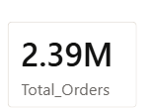

- Add a new column to your Power BI table for 'Order Ratings' (random numbers between 1 and 5 for each app). Use the AVERAGE function to show the average rating across all apps in a separate card.
ANSWERS:
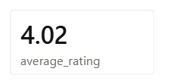

- Create a slicer in Power BI to filter your table by order ratings greater than 3. Use the COUNT and DISTINCTCOUNT functions to display the total number of orders and the count of unique apps with ratings above 3.
ANSWERS:
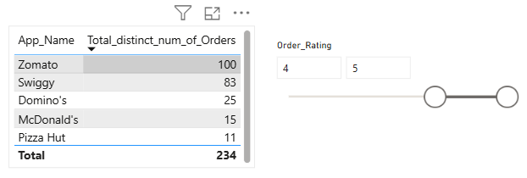

- Add a calculated column to your table that shows 'High Performer' if the app's order count is above the average, otherwise 'Regular', using the SWITCH function and logical operators (AND/OR). Display this new column in your table visualization.

Hint: Use VAR to store the average and RETURN to output the label based on the condition.
ANSWERS:

- Use Power BI's DAX editor to write a measure that returns 'Top Choice' if an app has more than 100 orders and a rating above 4, otherwise 'Consider Alternatives'. Use AND, IF, and NOT functions in your logic.
ANSWERS:
